Table of Contents

12 Devices to Protect Your Child 2

Crib Safety and Inspection 5

Furniture and TV Trip Over Hazards 7

Anti-tip Brackets for Free Standing Ranges 8

Window Falls 10

Child Proofing Windows and Stairs 11

Garage Doors and Openers 14

Trampoline Safety 15

Tree Swing Safety 18

Dedication 22

12 Safety Devices to Protect Your Children
About 2.5 million children are injured or killed by hazards in the home each year. The good news is that many of these incidents can be prevented by using simple child-safety devices on the market today. Any safety device you buy should be sturdy enough to prevent injury to your child, yet easy for you to use. It's important to follow installation instructions carefully.

In addition, if you have older children in the house, be sure they re-secure safety devices. Remember, too, that no device is completely childproof; determined youngsters have been known to disable them. You can childproof your home for a fraction of what it would cost to have a professional do it. And safety devices are easy to find. You can buy them at hardware stores, baby equipment shops, supermarkets, drug stores, home and linen stores, and through online and mail-order catalogues.

InterNACHI inspectors, too, should know what to tell clients who are concerned about the safety of their children. Here are some child-safety devices that can help prevent many injuries to young children.

1. Use safety latches and locks for cabinets and drawers in kitchens, bathrooms, and other areas to help prevent poisonings and other injuries. Safety latches and locks on cabinets and drawers can help prevent children from gaining access to medicines and household cleaners, as well as knives and other sharp objects.

Look for safety latches and locks that adults can easily install and use, but that are sturdy enough to withstand pulls and tugs from children. Safety latches are not a guarantee of protection, but they can make it more difficult for children to reach dangerous substances. Even products with child-resistant packaging should be locked away out of reach; this packaging is not childproof.

But, according to Colleen Driscoll, executive director of the International Association for Child Safety (IAFCS), "Installing an ineffective latch on a cabinet is not an answer for helping parents with safety. It is important to understand parental habits and behavior. While a latch that loops around cabinet knob covers is not expensive and easy to install, most parents do not consistently re-latch it."

Parents should be sure to purchase and install safety products that they will actually adapt to and use.

2. Use safety gates to help prevent falls down stairs and to keep children away from dangerous areas. Look for safety gates that children cannot dislodge easily, but that adults can open and close without difficulty. For the top of stairs, gates that screw into the wall are more secure than "pressure gates."

New safety gates that meet safety standards display a certification seal from the Juvenile Products Manufacturers Association (JPMA). If you have an older safety gate, be sure it doesn't have "V" shapes that are large enough for a child's head and neck to fit into.

3. Use door locks to help prevent children from entering rooms and other areas with possible dangers, including swimming pools.

To prevent access to swimming pools, door locks on safety gates should be placed high, out of reach of young children. Locks should be used in addition to fences and alarms. Sliding glass doors with locks that must be re-secured after each use are often not an effective barrier to pool access.

Door knob covers, while inexpensive and recommended by some, are generally not effective for children who are tall enough to reach the doorknob; a child's ingenuity and persistence can usually trump the cover's effectiveness.

4. Use anti-scald devices for faucets and shower heads, and set your water heater temperature to 120° F to help prevent burns from hot water. A plumber may need to install these.

5. Use smoke detectors on every level of your home and near bedrooms to alert you to fires. Smoke detectors are essential safety devices for protection against fire deaths and injuries. Check smoke detectors once a month to make sure they're working. If detectors are battery-operated, change batteries at least once a year, or consider using 10-year batteries.

6. Use window guards and safety netting to help prevent falls from windows, balconies, decks and landings. Window guards and safety netting for balconies and decks can help prevent serious falls. Check these safety devices frequently to make sure they are secure and properly installed and maintained. There should be no more than 4 inches between the bars of the window guard. If you have window guards, be sure at least one window in each room can be easily used for escape in a fire. Window screens are not effective for preventing children from falling out of windows.

7. Use corner and edge bumpers to help prevent injuries from falls against sharp edges of furniture and fireplaces. Corner and edge bumpers can be used with furniture and fireplace hearths to help prevent injuries from falls, and to soften falls against sharp and rough edges.

Be sure to look for bumpers that stay securely on furniture and hearth edges.

8. Use receptacle or outlet covers and plates to help prevent children from electrical shock and possible electrocution.

Be sure the outlet protectors cannot be easily removed by children and are large enough so that children cannot choke on them.

9. Use a carbon monoxide (CO) detector outside bedrooms to help prevent CO poisoning. Consumers should install CO detectors near sleeping areas in their homes. Households that should use CO detectors include those with gas or oil heat or with attached garages.

10. Cut window blind cords to help prevent children from strangling in blind-cord loops. Window blind cord safety tassels on miniblinds and tension devices on vertical blinds and drapery cords can help prevent deaths and injuries from strangulation in the loops of cords. Inner cord stops can help prevent strangulation in the inner cords of window blinds.

However, the IAFCS's Ms. Driscoll states, "Cordless is best. Although not all families are able to replace all products, it is important that parents understand that any corded blind or window treatment can still be a hazard. Unfortunately, children are still becoming entrapped in dangerous blind cords despite advances in safety in recent years."

For older miniblinds, cut the cord loop, remove the buckle, and put safety tassels on each cord. Be sure that older vertical blinds and drapery cords have tension or tie-down devices to hold the cords tight. When buying new miniblinds, vertical blinds and draperies, ask for safety features to prevent child strangulation.
11. Use door stops and door holders to help prevent injuries to fingers and hands. Door stops and door holders on doors and door hinges can help prevent small fingers and hands from being pinched or crushed in doors and door hinges.

Be sure any safety device for doors is easy to use and is not likely to break into small parts, which could be a choking hazard for young children.

12. Use a cell or cordless phone to make it easier to continuously watch young children, especially when they're in bathtubs, swimming pools, or other potentially dangerous areas. Cordless phones help you watch your child continuously without leaving the vicinity to answer a phone call. Cordless phones are especially helpful when children are in or near water, whether it's the bathtub, the swimming pool, or the beach.

In summary, there are a number of different safety devices that can be purchased to ensure the safety of children in the home. Homeowners can ask an InterNACHI inspector about these and other safety measures during their next inspection. Parents should be sure to do their own consumer research to find the most effective safety devices for their home that are age-appropriate for their children's protection, as well as affordable and compatible with their household habits and lifestyles.

Crib Safety and Inspection

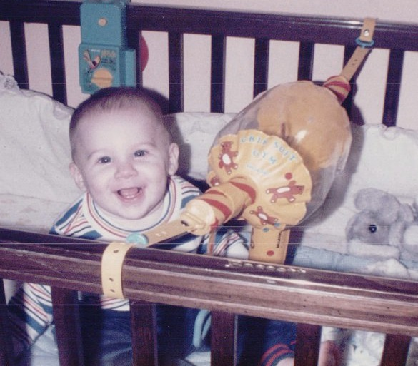
Defective cribs, especially hand-me-down and homemade models, can pose serious hazards to young children, including strangulation, entrapment and overheating. Government manufacturing standards set in 1973 have greatly improved crib safety, yet defective cribs continue to be responsible for the highest child injury rates of any nursery item. In fact, approximately 50 infants each year are killed and another 9,000 are injured in crib-related accidents in the U.S. To prevent an avoidable tragedy, parents should check their child’s crib to ensure against the following defects:
- Screws, bolts and hardware may not be missing, broken or loose.
- Slats cannot be more than 2-3/8 inches apart, which is about the width of a soda can, and none of them should be loose or broken. Older cribs are especially prone to this defect.
- The corner posts cannot extend more than 1/16-inch above the headboard and footboard.
- The mattress must be firm, and it should fit snugly inside the crib so that it does not easily release from the posts. This prevents the baby from getting stuck between the mattress and the crib.
- Check the overall condition. Look for any sharp points or edges (such as those on protruding rivets, nuts, bolts and knobs), and any wood surfaces that have splits, splinters or cracks.
- Lead paint was outlawed in the United States in 1978, so painted cribs made before this year should be tested for lead, or avoided altogether.
- There should be no decorative cutouts in the headboard or footboard in which the baby's head or limbs could get trapped.
- Decorative knobs and cornerposts should not be higher than 1/16-inch so that a baby's clothing cannot catch on them.
- The baby should sleep in a sleeper, as opposed to a blanket. Soft bedding and blankets are suffocation hazards. They may also cause the baby to overheat, so it’s best to remove all pillows, comforters and quilts from the crib.
- If the crib has ribbons or bows, make sure they are tightly fastened, and no longer than 8 inches.
- Mobiles are for looking at, not touching. Their parts present a choking hazard and can cause the baby to become entangled. Make sure your baby cannot reach the mobile, and when he is old enough to crawl, the mobile should be removed from the crib. While newer mobiles are designed so that they cannot be reached, the risks still exist for older mobiles, homemade mobiles, and mobiles not specifically designed for cribs.
Crib Recalls
Cribs that were manufactured between 2000 and 2009 may be included in a voluntary recall issued by the U.S. Consumer Product Safety Commission (CPSC) in June 2010. Seven firms will provide consumers with free repair kits to remedy more than 2 million defective cribs, and they advise consumers not to attempt to fix these cribs using homemade remedies. Consumers should contact manufacturers directly to learn the appropriate remedy. These manufacturers are listed below, along with the number of cribs they recalled.
- 750,000 Jenny Lind drop-side cribs distributed by Evenflo, Inc.;
- 747,000 Delta drop-side cribs. Delta is also urging parents to check all fixed and drop-side cribs that use wooden stabilizer bars to support the mattress. The company says the bars can be inadvertently installed upside-down, causing the mattress platform to collapse;
- 306,000 Bonavita, Babi Italia and ISSI drop-side cribs manufactured by LaJobi, Inc.;
- 130,000 Jardine drop-side cribs imported and sold by Toys R Us;
- 156,000 Million Dollar Baby drop-side cribs;
- 50,000 Simmons drop-side cribs; and
- 40,000 to 50,000 Child Craft brand (now Foundations Worldwide, Inc.) stationary-side cribs, and an unknown number of drop-side cribs.
In summary, parents should ensure a safe sleeping environment for their young children by learning about defective conditions commonly found in cribs.

Furniture and TV Tip-Over Hazards
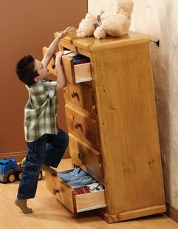
"A TV can be a child’s best friend, but it also can be a parent’s worst enemy,” says the mother of a 3-year-old who was crushed by a television, according to a 2009 Consumer Product Safety Commission (CPSC) study. The watchdog organization recently published an 18-year study on the dangers of furniture tip-overs, including startling findings that should be heeded by inspectors and parents alike.

Here are some facts and figures from the CPSC study:
- From 1990 to 2007, an average of nearly 15,000 children under 18 visited emergency rooms each year for injuries received from furniture tip-overs. The number shows a 40% increase in injury reports over the duration of the study, hinting that the problem is growing worse. About 300 fatalities were reported.
- Most injuries were to children 6 and under, and resulted from televisions tipping over.
- The most severe injuries were head injuries and suffocation resulting from entrapment.
- More than 25% of the injuries occurred when children pulled over or climbed on furniture.
- Most of the injured children were males under 7 who suffered blows to the head.
- The newer flat-screen TVs are not as front-heavy as the older, traditional TV sets, which means they may be less likely to tip over. Experts warn, however, that flat-screen TVs are still heavy to children, and they often have sharp, dangerous edges.
- In 2006, Pier 1 Imports announced the recall 4,300 TV stands after one of them resulted in the death of a child in Canada.
The American Society for Testing and Materials (ASTM) has established standards for manufacturers which stipulate that dressers, chests of drawers and armoires should be able to remain upright when any doors or all drawers are open two-thirds of the way, or when one drawer or door is opened and 50 pounds of weight are applied to the front, simulating a climbing child. In addition, Underwriters Laboratories (UL) requires units to be able to remain upright when placed on a 10-degree angle with 70 pounds on top, to simulate the weight of a television. The ASTM and UL standards are voluntary, however, and many manufacturers will cut corners to save money. And despite efforts by the CPSC to enforce these standards, sub-standard furniture is still regularly sold at retail stores.
Parents can minimize the risks posed to their children from furniture tip-overs by practicing the following strategies:
- Supervise young children at all times.
- Place televisions low to the ground and near the back of their stands.
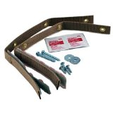
- Strap televisions and furniture to the wall with heavy safety straps or L-brackets. Many of these devices do not require that any holes be drilled into furniture, and they can secure items up to 100 pounds.
- Heavy items, such as televisions, should be placed far back on a dresser rather than at the front edge, which would shift the center of gravity forward and make the whole assembly more likely to tip over. Ideally, the center of gravity for furniture should be as low as possible, with the furniture placed back against a wall.
- Only purchase furniture that has a solid base, wide legs, and otherwise feels stable.
- Install drawer stops that prevent drawers from opening to their full extent, as a full extension can cause a dangerous forward-shift in the center of gravity.
- Keep heavier items on lower shelves and in lower drawers.
- Never place items that may be attractive to children, such as toys, candy or a remote control, on the top of a TV or piece of furniture.
- Do not place heavy televisions on dressers or shelving units that were not designed to support such weight.
- Place electrical cords out of the reach of children, and teach kids not to play with them. A cord can be used to inadvertently pull a TV, and perhaps its supporting shelf, onto a child.
- Read the manufacturer's instructions to learn about additional tips and hazards regarding the placement and use of your TV and furniture.
In summary, TVs and furniture can easily tip over and crush a small child if safety practices are not followed by parents.

Anti-Tip Brackets for Freestanding Ranges

Anti-tip brackets are metal devices designed to prevent freestanding ranges from tipping. They are normally attached to a rear leg of the range or screwed into the wall behind the range, and are included in all installation kits. A unit that is not equipped with these devices may tip over if enough weight is applied to its open door, such as that from a large Thanksgiving turkey, or even a small child. A falling range can crush, scald, or burn anyone caught beneath.

Bracket Inspection

Homeowners can confirm the presence of anti-tip brackets through the following methods:
- It may be possible to see a wall-mounted bracket by looking over the rear of the range. Floor-mounted brackets are often hidden, although in some models with removable drawers, such as 30-inch electric ranges made by General Electric, the drawers can be removed and a flashlight can be used to search for the bracket. Homeowners should beware that a visual confirmation does not guarantee that the bracket has been properly installed.
- Firmly grip the upper-rear section of the range and tip the unit. If equipped with an anti-tip bracket, the unit will not tip more than several inches before coming to a halt. The range should be turned off, and all items should be removed from the stovetop before this action can be performed. It is usually easier to detect a bracket by tipping the range than through a visual search. This test can be performed on all models and it can confirm the functionality of a bracket.
If no anti-tip bracket is detected, it is recommended that one be installed.

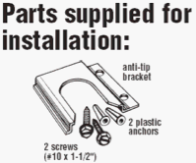
Homeowners can contact the dealer or builder who installed their range and request that they install a bracket. For homeowners who wish to install a bracket themselves, the part can be purchased at most hardware stores or ordered from a manufacturer. General Electric will send their customers an anti-tip bracket for free.

According to the U.S. Consumer Product Safety Commission (CPSC), there were 143 incidents caused by range tip-overs from 1980 to 2006. Of the 33 incidents that resulted in death, most of those victims were children. A small child may stand on an open range door in order to see what is cooking on the stovetop and accidentally cause the entire unit to fall on top of him, along with whatever hot items may have been cooking on the stovetop. The elderly, too, may be injured while using the range for support while cleaning.

In response to this danger, the American National Standards Institute (ANSI) and Underwriters Laboratories (UL) created standards in 1991 that require all ranges manufactured after that year to be capable of remaining stable while supporting 250 pounds of weight on their open doors. Manufacturers' instructions, too, require that anti-tip brackets provided be installed. Despite these warnings, retailer Sears estimated in 1999 that a mere 5% of the gas and electric units they sold were ever equipped with anti-tip brackets. As a result of Sears’ failure to comply with safety regulations, they were sued and subsequently required to secure ranges in nearly 4 million homes, a measure that has been speculated to have cost Sears as much as $500 million.

In summary, ranges are susceptible to tipping if they are not equipped with anti-tip brackets.

Window Falls
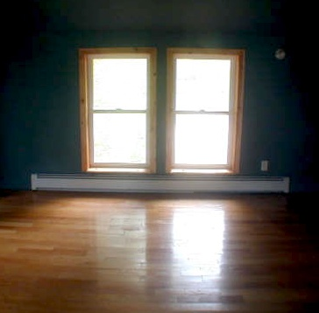
Every year, roughly 2.5 million children are treated in the United States for fall-related injuries. Of these, falls from windows tend to be the most serious and fatal, especially among male toddlers. Older children are more likely to be seriously injured by window falls as summer approaches and they spend more time around the home. This problem is heightened by the fact that windows are left open for ventilation more often during the summer months than the rest of the year. Inspectors should be ready to field questions from concerned clients, especially those with small children, about the dangers posed by falls from windows.
The following are window safety tips that inspectors can pass on to their clients:
- When ventilation is not needed, windows should be closed and locked.
- Windows can be equipped with window guards to prevent children from falling out. In some jurisdictions, such as New York City, window guards are required in apartments where children reside. These devices are constructed of horizontal bars spaced close enough together so that a 5-inch ball cannot pass through. Proper window guard placement can be determined by the local building code official or the local fire department. Window guards should include a quick-release mechanism to allow for a rapid exit in the case of an emergency.
- Furniture that children can climb, such as dressers, beds and toy chests, should be kept away from windows.
- Window screens are designed to keep insects outside of a house and should not be relied upon to keep children from falling out of windows.
- Shrubs, wood chips, grass or other soft surfaces may be strategically placed beneath windows in order to lessen the degree of injury sustained from falls.
- Children’s play areas should be kept away from open windows.
- If possible, ventilation should come from the upper sash of a double-hung window rather than the lower sash, which may be more accessible to a child.
- Windows that are low to the floor may be particularly easy for young children to operate. The inspector may point out low windows so the client understands their danger. The windows in the photo are low enough to be easily accessed by a small child.

Child-Proofing Windows and Stairs

The Number One hazard for children is falls, which are the leading cause of non-fatal injuries in the U.S. for this age group. About 8,000 youngsters wind up in emergency rooms every day for injuries related to falling, adding up to almost 2.8 million per year. With those statistics in mind, it is worth looking at what can be done to prevent such injuries in the home.
In trying to fathom how so many children can be injured on a daily basis from something as simple as slipping and falling, we need to consider an important factor, which is height. Oftentimes, when observing small children at play, we are amazed at their dexterity and ability to take what looks like a fairly serious tumble and hop right back up, unfazed. Likewise, a slip or fall for most adults, more often than not, leads to little more than a poorly chosen expletive being uttered. However, imagine a small child falling a distance equivalent to the average height of an adult, and we begin to see where the danger lies. With this to consider, let’s closer look at two of the most important areas to childproof in a home: windows and staircases.

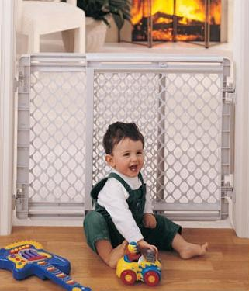
STAIRCASES
The first thing that probably comes to mind when examining child safety in relation to stairways and staircases is a safety gate, and with good reason: falling down stairs can be a serious hazard for an infant or toddler who is just learning to navigate his or her surroundings. When properly installed, high-quality safety gates can help eliminate this possibility.

Safety Gates
A safety gate is a gate that is temporarily installed in a door or stairway. It allows adults to unlock and pass, but small children will be unable to open it. There are two basic types of gates which differ in the way they are installed. The first type is a pressure-mounted gate. These safety gates are fixed in place by pressure against walls or a doorway. They can be used in doorways between rooms, such as for keeping crawling babies out of a kitchen during cooking, but they are not suitable for keeping kids out of other areas, such as the top of a stairway, where falling could be a risk.
The other type of safety gate, which is recommended specifically for stairways, is hardware-mounted. These gates will mount solidly in place with screws but are still easily removable for times when they are unnecessary. A hardware-mounted safety gate will prevent small children from entering stairways where accidents could occur.
When choosing a safety gate, you can refer to established ASTM standards for these products, and some manufacturers also participate in a certification program administered by the Juvenile Products Manufacturers Association. Any gate you choose should meet the ASTM standards, which will ensure that the gate itself poses no hazard to the child. Products that comply with these standards will have a sticker on the packaging or on the unit itself.
Railings
For parents of children who have outgrown the need for safety gates but are still small and curious, especially those prone to climbing on things, baluster spacing on the handrail becomes a concern. An InterNACHI inspector knows that a stairway with four or more risers should have a continuous handrail not lower than 34 inches or taller than 38 inches on at least one side, with balustrades not more than 4 inches apart from each other. If you have spaces between vertical rails or risers that will allow an object larger than 4 inches to pass between them, they should be reported during an inspection as in need of repair because they pose a risk to a child who tries to climb on the rail or gets stuck between them.
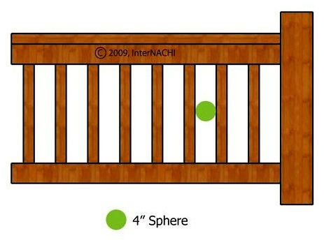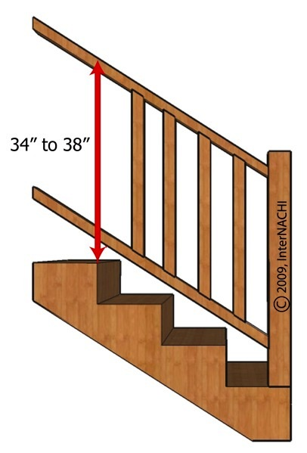

WINDOWS

If the dangers associated with falling are compounded by the height of the fall, then windows can present an even greater concern than stairways. It is estimated that more than 4,000 children are treated every year in emergency rooms for injuries sustained by falling from windows. There have been at least 120 such deaths reported since 1990. Risk of injury from window-related accidents in the home can be minimized by addressing
several common issues.
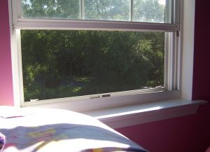
The first thing and simplest thing to do is to ensure that there is no furniture situated in areas that would make it easy for a child to reach and open or close a window. Any furniture a child could potentially climb on should be moved away from windows.

Latches, Stops and Guards

As children begin to grow to heights where they may be able to access windows from a standing position, it is important to install secure, child-proof latches. There are many types of window latches that, similar to safety gates, will allow an adult to easily open and close windows, but will prevent kids from doing the same.
Also available are window stops, which will not allow the window to be opened wider than a pre-determined width. The recommended opening, similar to balustrade spacing, should not exceed 4 inches. This eliminates the possibility of a child or one of his limbs to pass through. These stops are easily removable by an adult whenever necessary.
An additional option to consider is a window guard. A window guard can be vertical or horizontal. It attaches to a frame and can be removed by an adult, but will deter a child. Guards have some form of bars or beams across them, which should be no more than 4 inches apart. Window guards maintain the functionality of the window while ensuring a child’s safety while the window is open. However, even with a guard installed, kids should not be allowed to play around windows, whether they are open or closed. Try to open windows only from the top, if possible. And never rely on window screens to keep a child from falling, as that is not the function they are designed for.

With some foresight, a few clever and fairly inexpensive products, and proper adherence to building codes, the risk of injury from falling can be successfully minimized. Your InterNACHI inspector can assess the safety issues in your home, and advise you on the most effective childproofing measures to keep your family safe.

Garage Doors and Openers

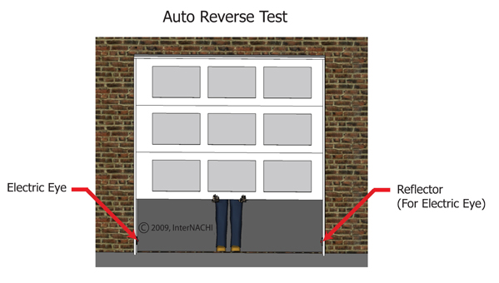
Garage doors are large, spring-supported doors. Garage door openers control the opening and closing of garage doors, either through a wall-mounted switch or a radio transmitter. Due to the strain that garage door components and openers regularly endure, they may become defective over time and need to be fixed or replaced. Defective components may create safety hazards as well as functional deficiencies to the garage door assembly. The following facts demonstrate the dangers posed by garage doors:
- Garage doors are typically among the heaviest moving objects in the home and are held under high tension.
- Injuries caused by garage doors account for approximately 20,000 emergency room visits annually, according to the U.S. Consumer Product Safety Commission.
- The majority of the injuries caused by garage doors are the result of pinched fingers, although severe injuries and deaths due to entrapment occur as well. Sixty children have been killed since 1982 as a result of garage doors that did not automatically reverse upon contact.

Methods for testing the automatic reverse system:
- This safety feature can be tested by grasping the base of the garage door as it closes and applying upward resistance. Inspectors should use caution while performing this test because they may accidentally damage its components if the door does not reverse course.
- Some sources recommend placing a 2x4 piece of wood on the ground beneath the door, although there have been instances where this testing method has damaged the door or door opener components.
- Supplemental automatic reverse system. Garage doors manufactured in the U.S. after 1992 must be equipped with photoelectric sensors or a door
edge sensor.
  - Photoelectric eyes. These eyes (also known as photoelectric sensors) are located at the base of each side of the garage door and emit and detect beams of light. If this beam is broken, it will cause the door to immediately reverse direction and open. For safety reasons, photo sensors must be installed a maximum of 6 inches above the standing surface.
  - Door edge sensors. This device is a pressure-sensitive strip installed at the base of the garage door. If it senses pressure from an object while the door is closing, it will cause the door to reverse. Door edge sensors are not as common in garage door systems as photoelectric eyes.

Safety Advice for Homeowners:
- Homeowners should not attempt to adjust or repair springs themselves. The springs are held under extremely high tension and can snap suddenly and forcefully, causing serious or fatal injury.
- No one should stand or walk beneath a garage door while it is in motion. Adults should set an example for children and teach them about garage door safety. Children should not be permitted to operate the garage door opener push button and should be warned against touching any of the door’s moving parts.
- Fingers and hands should be kept away from pulleys, hinges, springs, and the intersection points between door panels. Closing doors can very easily crush body parts that get between them.
- The automatic reversal system may need to be adjusted for cold temperatures, since the flexibility of the springs are affected by temperature. This adjustment can be made from a dial on the garage door opener, which should only be changed only by a trained garage door technician.

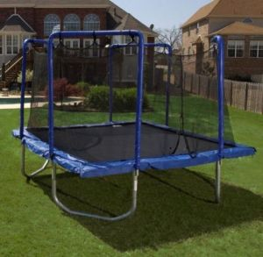
Trampoline Safety

While health-promoting and fun, trampolines can also be dangerous when they're misused, or if they're poorly designed.

Facts and Figures
- The first modern trampoline was constructed in 1936 by University of Iowa gymnasts George Nissen and Larry Griswold. Trampoline-like devices have been in use for centuries, however, such as walrus skins used by the Inuit to toss each other into the air.
- According to the American Association of Orthopedic Surgeons (AAOS), an average of 246,875 trampoline injuries requiring medical treatment occur annually in the U.S. Of this total, the majority -- 186,405 -- occur among children ages 14 and younger. The most common injuries resulting in hospitalization include fractures to the upper and lower extremities. Catastrophic spine injuries are rare, but head and neck injuries constitute a large portion of the more serious reported injuries.
- Most reported injuries and deaths are caused by children colliding with each other, landing improperly while jumping or doing stunts, falling off the trampoline, or falling on the trampoline springs or frame.
- The American Academy of Pediatrics recommends that home trampolines not be used at all. Parents may consider other forms of activity for their children to enjoy, or visit a commercial trampoline park, whose standards for construction must follow strict safety guidelines.
Trampoline users should practice the following safety tips in order to avoid injury:
- Allow only one person on the trampoline at a time.
- Use a trampoline that is located in a well-lit area.
- Children should never be allowed to jump onto the trampoline from high objects, such as trees or roofs.
- Always supervise children who use the trampoline, and never allow a child under the age of 6 to use a full-size trampoline.
- Leave the gymnastics to the professionals. The U.S. Consumer Product Safety Commission cautions against performing somersaults on trampolines because landing on the head or neck can cause paralysis. The user should never attempt maneuvers beyond their capability or training.
In addition to safe behavior, trampolines can be arranged to limit the chance of injury using these guidelines:
- Install a surrounding net. These nets have been shown to reduce the number of injuries from falls off the trampoline, although they are no substitute for supervision, and they do not protect against injuries sustained on the trampoline, according to the Foundation for Spinal Cord Injury Prevention.
- Safety pads should cover all portions of the steel frame, hooks and springs.
- Never place the trampoline on concrete or asphalt. It’s wise to apply wood chips or some other soft surface to the surroundings.
- Never install a trampoline near structures, power lines, clotheslines, trees, or anything else that may contact a bouncing child.
- The condition of the trampoline should be regularly inspected for tears, rust, and detachments.
- Safety harnesses and spotting belts, when appropriately used, may offer additional protection for athletes practicing more challenging skills on the trampoline.
- Trampolines that are set over pits so that the mat is at ground level may be safer because the user will not fall as far if they miss the pad.
- Do not attach a ladder to the trampoline because it can provide unsupervised access for small children.
Trampolines and Homeowners Insurance
Trampolines are considered by insurance companies to be an "attractive nuisance" -- something that invites trespassers – and, as such, insurers don't automatically provide coverage for them in their homeowners policies. No matter what signs are posted or gates erected, there is always a possibility that a neighborhood child will trespass, get injured on the trampoline, and sue you in court.

Mary Kaderbek of Allstate® Insurance reminds homeowners that "owning a trampoline can affect your homeowners insurance," so they should check their policies or give their agents a call before purchasing a trampoline.

Most insurers handle trampolines in one of three ways:
- No Exclusions: This means that there are no restrictions on owning or using a trampoline on the covered property. While it may be the most desirable coverage, it may not be a standard offering by your insurer;
- Coverage with Safety Precautions: This type of coverage is for trampolines that have safety features installed, such as padded coverings for springs, a netting enclosure, a locking yard gate, etc.; and
- Trampoline Exclusion: The most restrictive clause, this means that trampolines are excluded from your homeowners coverage, so any damage or injury caused by anyone (invited or not) who uses a trampoline on the insured property is not covered. Furthermore, if a homeowner purchases a trampoline after purchasing the policy, the policy may not be renewed
In summary, trampolines can cause bodily harm -- and financial hardship -- if not used responsibly. And, as with any major purchase for the home, homeowners should check with their insurance carriers to find out what kind of liability they may face by setting up a trampoline in their yard.

Tree Swing Safety
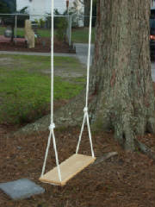
A tree swing (or a rope swing or tire swing) is composed of a single rope or chain attached to a high tree branch, along with a seat, which is typically a wooden plank or tire. For many homeowners, tree swings represent fond childhood memories, but this type of DIY play equipment is too often poorly constructed by non-professional builders for their children, who can be unaware of the potential dangers. InterNACHI inspectors who encounter these at property exteriors may wish to alert their clients of some of the hazards they pose.
Consider some recent tragedies. In 2010, a British girl enjoying her tree swing was killed when she was pinned to the ground by the falling silver birch, which is a tree species considered unsuitable for tree swings. That same year, an unsupervised boy accidentally hanged himself when he became tangled in the tree swing’s rope. Children are also killed or injured when ropes snap or hanger brackets dislodge. An article in the journal Pediatrics stated that “Recreational, single-rope tree swing injuries among children resulted in significant morbidity, regardless of the height of the fall. This activity carries a substantial risk for serious injury.”
To prevent accidents, inspectors and their clients can learn about what goes into a properly installed tree swing, and how to inspect them for potential hazards.
Tree Inspection
A sturdy tree is a must for a safe tree swing, but this consideration may be overlooked on properties that lack a variety of healthy trees from which to choose. Also, inspectors should remember that while trees appear stationary, they are actually alive and constantly, albeit slowly, growing and changing shape. As such, branches will “absorb” hanger brackets, and overhead branches will become brittle, gradually transforming what was once a properly installed tree swing into one that is no longer safe to use.
Check for the following indications that the tree will pose dangers to the user:
- inappropriate tree choice. According to London Play, an organization that promotes outdoor exercise for children, beech, oak, sycamore and Norway maple are suitable for rope swings, while pine, poplar, spruce, willow and silver birch should be avoided. Cherry, cedar and ash can be used only when their limbs are large and the tree is in good condition;
- the branch is too thin. The branch’s minimum thickness depends on the tree species, but, in general, it should be at least 8 inches thick;
- bulges, cracks and unusual swelling. These tree defects often lead to limb failure. If possible, the candidate limb should be inspected from above as well as from the ground;
- decay, fungus, or signs of hollowing within the tree. Dead wood is often dry and brittle and cannot bend in the wind under the stresses of the weight of a swinging child. Strike the tree at different points with a hammer to test for the sound of hollowing;
- poor tree architecture. While a tree that naturally leans may have no structural defects, straight trees that have started to lean recently may be damaged and in danger of collapse;
- cracks or seams where the branch forks from the larger limb. Weak unions indicate that the limb is at risk of tearing out; and
- dead or hanging branches above the swing. These should be secured or removed, as they are likely to dislodge from the motion of the moving swing.
Ground Cover
Whether on purpose or by accident, sooner or later, children will fall from playground equipment, including rope swings, and the extent of their injuries will be determined, in part, by the condition of the ground beneath the swing.
Inspect for the following hazards that may make injuries more likely:
- asphalt, concrete or other types of hard surfaces. Grass or bare earth covered with leaves is usually safe, although additional safety can be provided by loose-fill material, such as mulch, wood chips, shredded rubber mulch, or engineered wood fiber. Earth that has been compacted by frequent foot traffic may be too hard;
- natural objects that may be tripped over or injure a child, such as rocks, exposed roots, stumps or branches from a neighboring tree. These objects should be removed so that only a flat surface remains;
- downward-sloped terrain. This will have the effect of accelerating the speed or adding to the distance for the child to dismount the swing, increasing the likelihood that s/he will trip and fall. Such a slope will also encourage the loss of leaves and other natural loose-fill material to wind and rain; and
- safe ground surface that extends only in a narrow path in front of and behind the swing. Tire swings, which permit a swinging motion in any axis, demand a larger safe-ground surface than other rope swings. The U.S. Consumer Product Safety Commission (CPSC) recommends installing a protective surface outward from the swing equal to the suspension rope plus 6 feet.
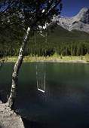
Water
Tree swings are sometimes installed adjacent to ponds or rivers so the user has the option of a water landing. As exciting as this prospect may be, water presents its own set of dangers. A flotation device may be kept next to the tree so that it can be thrown into the water in case of an emergency.
Also, check for the following:
- water depth. Check to make sure that the water is sufficiently and uniformly deep within the fall range;
- sharp rocks, branches or other objects that can cause injury; and
- obvious exit. A steep-walled river can be difficult to escape, as can swift river currents.
Rope
A tree swing is only as strong as its rope or chain, so care should be taken to choose adequate material.
Check for the following rope defects:
- too thin. Rope that is too thin will either not support the weight of a swinging child or be difficult to adequately grasp;
- too thick. Ensure that the rope is not so thick that a child cannot easily grasp it. Rope that is an inch to 1-1/2 inches thick is typically sufficient, depending on the material;
- inadequate strength. Remember that as the user swings higher and higher, the tension in the rope or chain will equal several times the rider’s weight at the bottom of the arc. Therefore, the rope should be rated to withstand significantly greater weight than that of the intended rider;
- abrasiveness. Before wrapping the rope around the tree limb, protect the tree from abrasion and subsequent damage and weakening by wrapping a section of rubber around it; and
- unsafe, makeshift or additional ropes. Ensure that the rope does not create strangulation hazards. Also, check for any stray jump ropes, clotheslines, pet leashes, or anything else unnecessarily attached to the tree swing.
Seat
The seat should be high enough so that the user’s legs do not scrape the ground but not so high that the swing isn’t easily accessible or requires unsafe effort for the user to dismount. Remember that tree limbs can sway under the user’s weight, and weaker limbs might permit the seat to get too close to the ground. Sufficient clearance is roughly 10 inches between the ground and the user, which may translate into 16 inches for an unoccupied swing. A seat may be made from a wooden plank, which can be inspected for splinters, or a tire, which is usually suspended in a horizontal orientation using three suspension chains or cables connected to a single swivel mechanism that permits both rotation and a swinging motion in any axis.
The tire may be a discarded vehicle tire or a plastic imitation, but it can present its own set of defects, including:
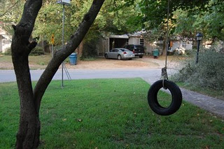
- exposed metal wires. Newer radial tires should not be used for a swing. In fact, the American Society of Testing and Materials (ASTM) explicitly advises against their use because they can become worn, exposing dangerous metal wires. Radial tires should be closely inspected for wear before their use. Older bias tires are usually safer to use for swings;
- using a heavy truck tire. This type of tire may be too heavy, causing the hanger clamp to dislodge. According to the ASTM, the entire rope swing assembly should not be greater than 35 pounds;
- no water drainage holes. Tires will collect rainwater if they lack holes through which water can drain; and
- beehives or hornets’ nests. Carefully inspect the interior of the tire for dangerous animals and insects and their nests, especially stinging insects, which may require special handling in order to remove safely.
Hanger Clamp
Hanger clamps provide a fixed point for the rope and the tree branch to intersect while keeping them properly separated, reducing friction on the rope than can cause it to gradually wear away. The likelihood of failure at this point is increased due to the additional stress of rotational movement and multiple users.

Check for the following defects:
- poor clamp location. The hanger should be installed far enough away from the tree trunk that the user cannot inadvertently swing into the tree, especially if the swing permits horizontal motion. Likewise, the hanger should be placed at a point on the branch close enough to the tree trunk that the branch is of desirable strength and thickness;
- the clamp is not securely installed. If it detaches, the swing and its rider will fall to the ground. The CPSC has ordered a recall of tire swings manufactured by Miracle Recreation Equipment Company (model #714-852, #714-852-X and #278) for this safety defect due to reported injuries; and
- pinch points. Hanger clamps, especially for multi-axis tire swings, should not have any accessible pinch points.
Additional Inspection Tips
- Check for signs of vandalism. Even if intended as a harmless prank, disaster can result from a partially cut rope.
- Supervise children at play. Children may stand on the swing, swing excessively high to outdo a friend, or spin the swing to create dizziness. A little supervision can mean the difference between childhood antics and serious danger.
- Remove drawstrings from children’s clothing, as they can become attached to the moving swing and create a strangulation hazard.
- Remove the swing in bad weather if it may become damaged or damage the tree.
- Clean, sand and repaint rusted areas as needed.
- Occasionally inspect the condition of the equipment for signs of wear (especially after a season of harsh or inclement weather), such as splintering wooden surfaces, damaged suspension ropes, broken and missing components, and bent pipes or tubing.
- Ensure that protective caps and plugs which cover bolt and tubing ends are in place and secure.
- Periodically oil any moving metal parts.
- Maintain loose-fill surfacing beneath the swing.

Dedication
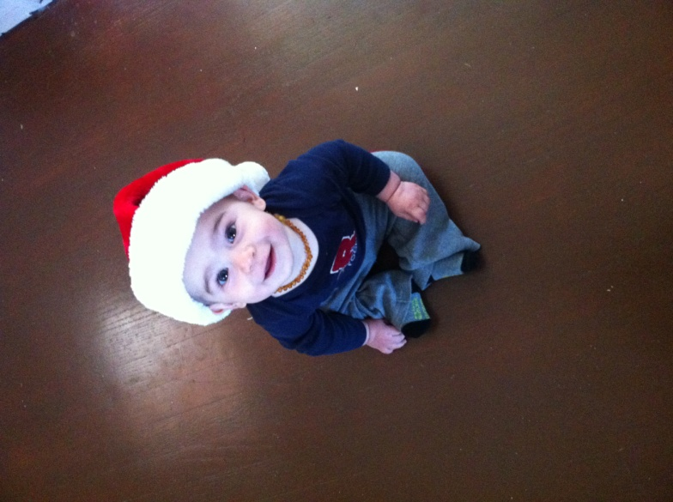
This book is dedicated to our newest bundle of joy. His smile lights up our day, and we are committed to keeping our home safe for him, and other son. We hope this book provides helpful safety insights, so that all families can keep their precious ones safe. If you have any questions, or feedback please write to us at info@ahouseonarock.com

